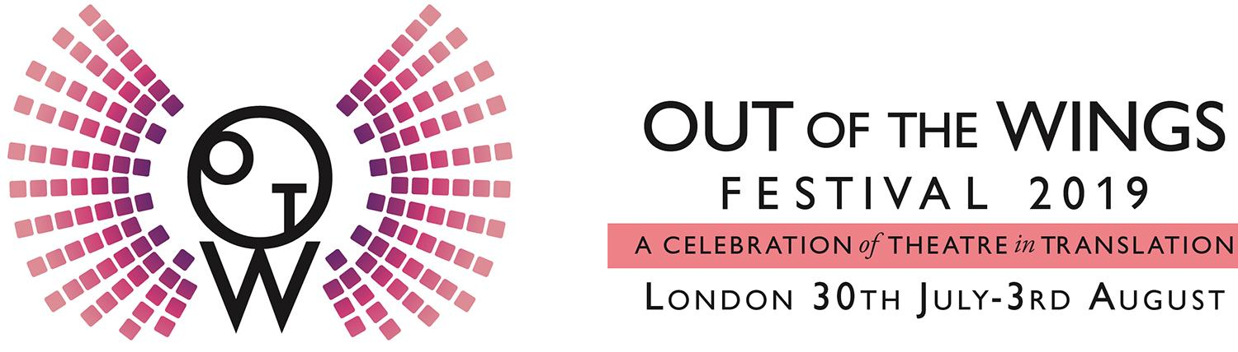

Out of The Wings presents its 2019 Festival

Release: London, June 2019
Out of the Wings presents its fourth annual festival of theatre from the Spanish and Portuguese-speaking world. From 30 July to August 03 at the Omnibus Theatre, Clapham, a series of staged readings bring to life new English translations of works by playwrights from six countries, alongside workshops, talks and events.

This year’s programme includes writers from Chile, Portugal, Uruguay, Spain, Colombia and Cuba, with plays dating from the mid-20th Century to the present day. In a showcase of the breadth and variety of Iberoamerican playwriting, the plays take on themes of loss and belonging, love and family, political correctness, obsession, resilience and creativity. Showcasing the work of some of their country’s leading dramatists as well as emerging voices, Out of the Wings brings together writers, translators, other theatre-makers and audiences of all backgrounds to share international stories as yet unheard in the UK.

Alongside the plays, Out of the Wings will also host three practical, interactive workshops at the Omnibus on the theme of theatre in translation, exploring translation for radio drama, the role of objects and emotions in translating a play, and the experience of working with real-life characters. The evening readings will be followed by post-show events including discussions with the playwrights, music, and other festivities. The festival also includes a one-day forum of panels, debate and networking on the themes of international theatre and translation for the stage, hosted by King’s College London with Goldsmiths University of London and Language Acts and Worldmaking.

Play Readings (Omnibus Theatre, 7:30pm, £10/£7.50)

Tue 30 July: CASSANDRA, SANDRA by Gabriela Aguilera (Chile), translated by William Gregory, directed by Kate O’Connor

Wed 31 July: FERNANDO AND HIS GRANDMOTHER by Armando Nascimento Rosa (Portugal), translated by Susannah Finzi, directed by Almiro Andrade

Thu 01 Aug: HER OPEN EYES by Raquel Diana (Uruguay), translated by Sophie Stevens, directed by Fran Olivares

Fri 02 Aug: BAD JOKE by Jordi Casanovas (Catalonia/Spain), translated by Tim Gutteridge, directed by Dadiow Lin

Sat 03 Aug: FREDDIE by Abilio Estévez (Cuba), translated by Kate Eaton, and scenes from COMPLEMENTO by Rafael Guizado (Colombia), translated by Gigi Guizado, a double-bill directed by Camila González

Workshops (Omnibus Theatre, 2pm, £7/£5)

Wed 31 July: TRANSLATING RADIO DRAMA

Thu 01 Aug: PLAYING THE REAL

Fri 02 Aug: OBJECTS, EMOTIONS AND THE TRANSLATED PLAY

One-Day Forum (King’s College London, 9:30am, £15/£9)

Tue 30 July: THEATRE TRANSLATION BEYOND THE STAGE

Full programme details and tickets:
https://ootwfestival.com/
https://omnibus-clapham.org/out-of-the-wings-fest/

About out of the Wings:

Out of the Wings began life as a research project, leading to a unique archive of plays from Spain and Spanish America: outofthewings.org. In recent years the project has grown to include work from Portuguese-speaking writers, and has developed into a collective of theatre artists, researchers, producers and other colleagues, all with the shared goal of showcasing and exploring international theatre. Out of the Wings is active throughout the year, and meets every month to read and discuss new translations of Spanish- or Portuguese-language plays. New members from all disciplines are always welcome. To learn more, email info@outofthewings.org.

About Omnibus Theatre:

Omnibus Theatre is a multi award-winning independent theatre in Clapham, South London. Finalist in the Fringe Theatre of the Year 2019 The Stage Awards, A recipient of the Peter Brook/Royal Court Theatre Support Award 2016 and Offie winner 2018. The heart of our ambitious programme, inspired by our building’s literary heritage, lies in both classics re-imagined and contemporary storytelling. We provide a platform for new writing and interdisciplinary work, aiming to give voice to the underrepresented and challenge perceptions. We believe in affordable tickets and theatre for all. Since opening in 2013 notable in-house productions include Woyzeck (2013), Macbeth (2014), Colour (2015), Mule (2016), Spring Offensive(2017) and Zeraffa Giraffa (2017). Omnibus Theatre is led by Artistic Director Marie McCarthy. Patrons include Dame Judi Dench, Sir Michael Gambon, Matthew Warchus, Sir Richard Eyre and Maggi Hambling. We are a registered charity and receive no core funding. Omnibus_theatre | @Omnibus_Theatre

Contact info:

Name: Catherine Boyle
Organization: Out of the Wings
Phone: +44 (0)20 7848 2605
Email: info@outofthewings.org
Twitter: @outofthewings
Facebook: outofthewings
Hashtag: #OOTW2019

